Name :SK.Kashifa

Regitration no :192121135

BPO Management system

Class diagram :

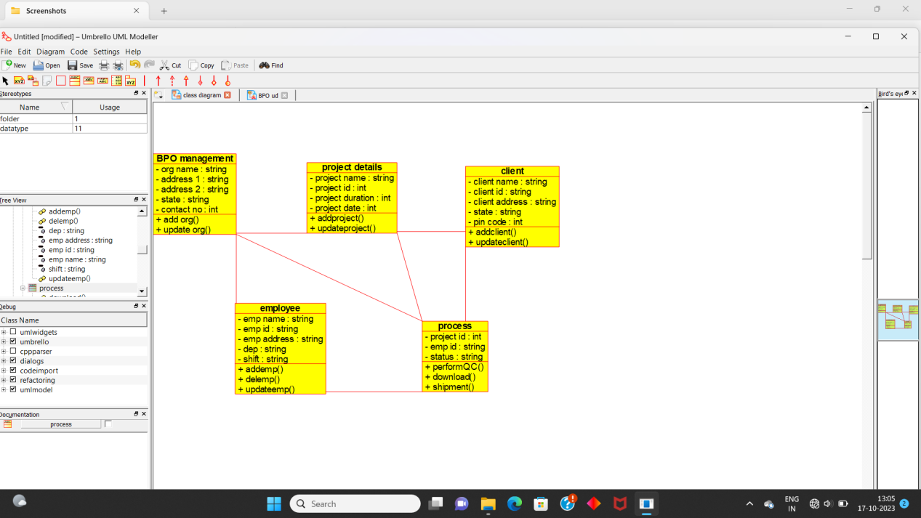

Usecase diagram :

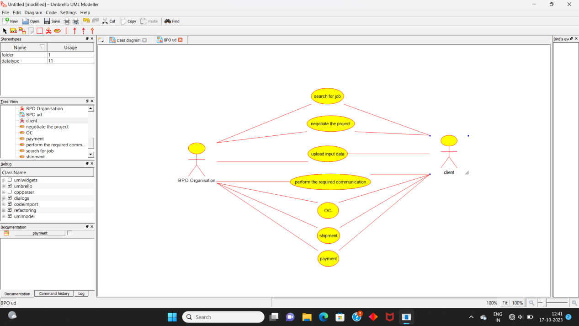

Sequence diagram :

